1. Agenda:
   1. How to assign a consumer app to a group.
2. 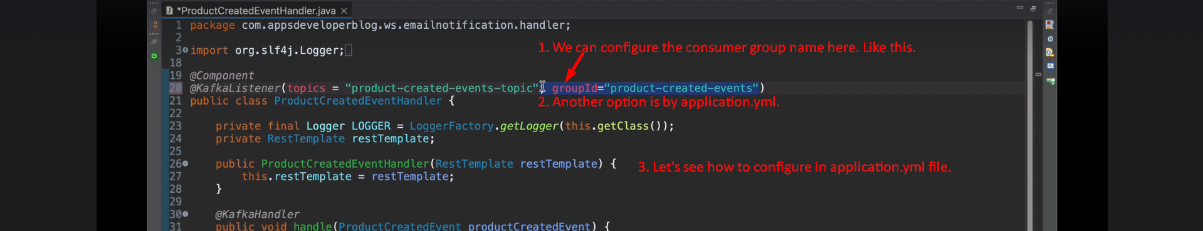  
     
     
   Above the property name for the consumer group is a standard name which will be picked by the Spring Auto configuration for consumer.
3. Another way is via consumer factory.
4. So, what we will do, we will define a custom property in application.yml not standard.   
     
   Then we will read that property in java code to set in ConsumerFactory.   
   